**4: A barbershop employs a single barber to serve the customers. Customers arrive every 3.34±1.7 minutes and takes 6.66±1.71 minutes to complete. Simulate the operation of the barbershop for 1 hour. Determine the utilization of the barber.**

**it**

**Code:**

GENERATE 3.34,1.7

QUEUE Barber

SEIZE Barber

DEPART Barber

ADVANCE 6.66,1.71

RELEASE Barber

TERMINATE 0

GENERATE 60

TERMINATE 1

**Journal Entry:**

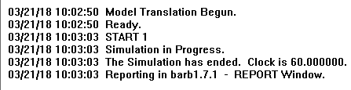

**Report:**

